## Problem 2 – Labyrinth Escape

### You are given a rectangular field of size NxM, filled with numbers and directions. On each cell on the field there will be a direction marked with the letters l, r, u, d.

By given position **(R, C)** (Rth row and Cth column) the directions are as follows:

From **(R, C) go l** => **(R, C-1)**

From **(R, C) go r** => **(R, C+1)**

From **(R, C) go u** => **(R-1, C)**

From **(R, C) go d** => **(R+1, C)**

### The numbers in the field are always as follows:

### On the first row the values are from 1 to M, on the second row – from M+1 to 2*M, on the third row – from 2*M +1 to 3*M, on the Nth row – from (N-1)*M to N*M.

### By given start position, find the path outside of the field, or print if you are lost.

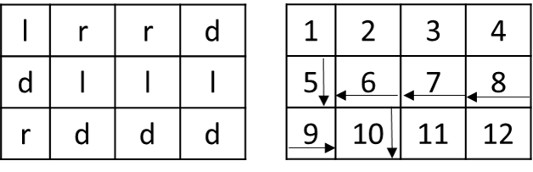**Example:**

N = **3**

M = **4**

Start position: **1 3**

### Input

The method Solve accepts a zero-based array of strings. The arguments are as follows:

**args[0]** contains **N** and **M** separated by a single space (" ")

**args[1]** contains **R** and **C** – the **start position** (the start position is zero-based)

**args[2]** to **args[N+2]** contain exactly **M characters**(only the letters 'l', 'r', 'u' or 'd')

### Output

The output data should be printed on the console.

The output should contain a single string – "**out SUM_OF_NUMBERS_IN_THE_PATH**" or "**lost NUMBER_OF_CELL_IN_THE_PATH**"

**"out SUM_OF_NUMBERS_IN_THE_PATH"** means the at some point you can go outside of the field

**"lost NUMBER_OF_CELL_IN_THE_PATH"** means that you are stepping on a cell that is already visited

### Constraints

* **N** and **M** will be always between **1** and **500**
* Allowed working time for your program: 0.2 seconds. Allowed memory: 16 MB.

### Examples

|  |  |
| --- | --- |
| **Input example** | **Output example** |
| args =[  "3 4",  "1 3",  "lrrd",  "**dlll**",  "**rd**dd"] | out 45 |
| args =[  "5 8",  "0 0",  "**rrrrrrrd**",  "rludulr**d**",  "**d**urlddu**d**",  "**u**rrrldu**d**",  "**ulllllll**"] | lost 21 |
| args =[  "5 8",  "0 0",  "**rrrrrrrd**",  "rludulr**d**",  "**l**urlddu**d**",  "**u**rrrldu**d**",  "**ulllllll**"] | out 442 |